What is Machine Learning?

Machine Learning (ML) is that field of computer science with the help of which computer systems can provide sense to data in much the same way as human beings do.

## Applications of Machines Learning

Machine Learning is the most rapidly growing technology and according to researchers we are in the golden year of AI and ML. It is used to solve many real-world complex problems which cannot be solved with traditional approach. Following are some real-world applications of ML −

* Emotion analysis
* Sentiment analysis
* Error detection and prevention
* Weather forecasting and prediction
* Stock market analysis and forecasting
* Speech synthesis
* Speech recognition
* Customer segmentation
* Object recognition
* Fraud detection
* Fraud prevention
* Recommendation of products to customer in online shopping

## Challenges in Machines Learning

While Machine Learning is rapidly evolving, making significant strides with cybersecurity and autonomous cars, this segment of AI as whole still has a long way to go. The reason behind is that ML has not been able to overcome number of challenges. The challenges that ML is facing currently are −

**Quality of data** − Having good-quality data for ML algorithms is one of the biggest challenges. Use of low-quality data leads to the problems related to data preprocessing and feature extraction.

**Time-Consuming task** − Another challenge faced by ML models is the consumption of time especially for data acquisition, feature extraction and retrieval.

**Lack of specialist persons** − As ML technology is still in its infancy stage, availability of expert resources is a tough job.

**No clear objective for formulating business problems** − Having no clear objective and well-defined goal for business problems is another key challenge for ML because this technology is not that mature yet.

**Issue of overfitting & underfitting** − If the model is overfitting or underfitting, it cannot be represented well for the problem.

**Curse of dimensionality** − Another challenge ML model faces is too many features of data points. This can be a real hindrance.

**Difficulty in deployment** − Complexity of the ML model makes it quite difficult to be deployed in real life.

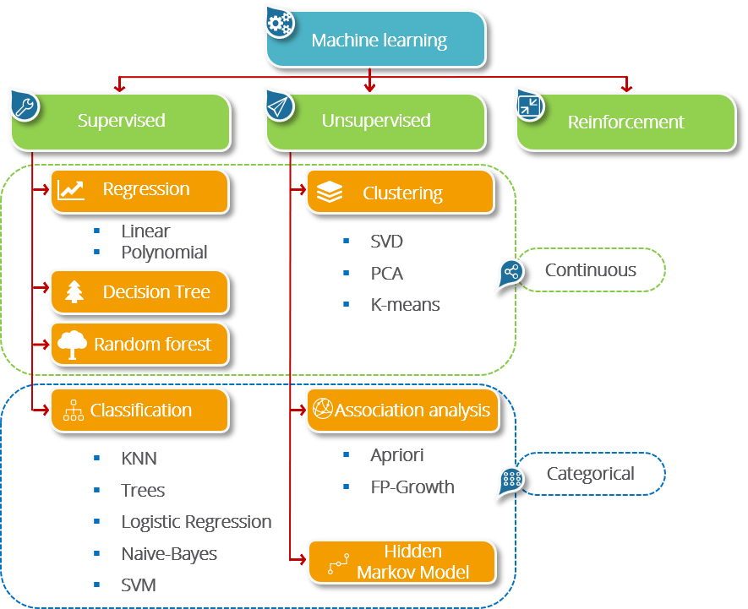

## What is Supervised Learning?

Supervised Learning is the one, where you can consider the learning is guided by a teacher.

We have a dataset which acts as a teacher and its role is to train the model or the machine.

Once the model gets trained it can start making a prediction or decision when new data is given to it.

## What is Unsupervised Learning?

The model learns through observation and finds structures in the data. Once the model is given a dataset,

it automatically finds patterns and relationships in the dataset by creating clusters in it.

What it cannot do is add labels to the cluster, like it cannot say this a group of apples or mangoes, but it will separate all the apples from mangoes.

Suppose we presented images of apples, bananas and mangoes to the model, so what it does, based on some patterns and relationships it creates clusters and divides the dataset into those clusters. Now if a new data is fed to the model, it adds it to one of the created clusters.

## What is Reinforcement Learning?

It is the ability of an agent to interact with the environment and find out what is the best outcome.

It follows the concept of hit and trial method. The agent is rewarded or penalized with a point for a correct or a wrong answer, and on the basis of the positive reward points gained the model trains itself.

And again once trained it gets ready to predict the new data presented to it.